**LOCATIONS (WHERE)**

1. Where are the speakers?  
(A) At a gas station.  
(B) In an elevator.  
(C) In a kitchen.  
(D) In an office.

2. Where are the speakers?  
(A) At a fish store.  
(B) At a restaurant.  
(C) At the beach.  
(D) At a party.

3. Where are the speakers?  
(A) In a theater.  
(B) On a train.  
(C) In a plane.  
(D) In a grocery store.

4. Where will the woman return the book?  
(A) To the bookstore.  
(B) To the library.  
(C) To her friend.  
(D) To the post office.

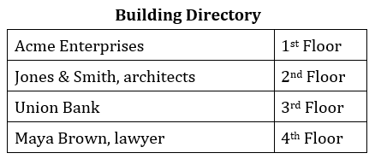5. Look at the graphic. Where is the accountant’s office??  
(A) 1st floor.  
(B) 2nd floor.   
(C) 3rd floor.  
(D) 4th floor.

6. Where are the speakers?  
(A) At an import company.  
(B) At a restaurant.  
(C) At a hotel.  
(D) At an airport.

7. Where is this conversation taking place?  
(A) At a bank.  
(B) At a bookstore.  
(C) At a lost and found.  
(D) At a library.

8. Where are the speakers going?  
(A) To the train station.  
(B) To the watch repair shop.  
(C) To a grocery store.  
(D) To a coffee shop.

9. Where is this conversation taking place?  
(A) In Hawaii.  
(B) At a travel agency.  
(C) On a plane.  
(D) In a gift shop.

10. Where are the speakers?  
(A) At a driving school.  
(B) At an insurance agency.  
(C) At a car rental agency.  
(D) At an automobile showroom.